ShopFlow Capstone Project
Name : Emmanuel Atty A

1. Introduction
This report documents the end-to-end build-out of ShopFlow, a small but realistic e-commerce microservices system deployed on Amazon EKS. The project was completed in three stages: Phase 1 stood up the core system — a React storefront, three Spring Boot backend services (Catalog, Orders, Notifications), a managed Postgres database, and an SQS-based event queue, all running on Kubernetes. Phase 2 turned that working system into something closer to a production platform by adding centralized secrets management, IAM-based pod identity, monitoring, centralized logging, autoscaling, network policy segmentation, and Helm-based packaging. The final stage implemented a fully gated CI/CD pipeline using Jenkins, SonarQube, Nexus, and Trivy, so that every code change is automatically built, tested, scanned for vulnerabilities, and deployed.
The sections below walk through what was built, present screenshots as evidence of each working component, and close with an honest account of the technical problems encountered along the way and how each was diagnosed and resolved. Troubleshooting real infrastructure problems was, in practice, the majority of the actual work — that process is documented in detail in Section 6.

2. Architecture Summary
The system is organized as four application components behind a single AWS Application Load Balancer:
- Storefront (React + nginx) — serves the web UI and proxies API calls to the backend services.
- Catalog Service (Spring Boot) — reads product data from PostgreSQL (Amazon RDS).
- Orders Service (Spring Boot) — validates orders against Catalog, persists them to RDS, and publishes an event to Amazon SQS.
- Notifications Service (Spring Boot) — consumes order events from SQS and issues confirmations, decoupled from Orders entirely.
All four services run as Kubernetes Deployments on Amazon EKS, provisioned by Terraform (VPC, subnets, EKS cluster, RDS instance, ECR repositories, and the SQS queue) and, from Phase 2 onward, deployed as a single Helm chart rather than hand-applied manifests.

3. Phase 1 — Building the Core System
Phase 1 focused on getting a working distributed system running end to end: infrastructure provisioning with Terraform, container images built and pushed to ECR, and the four services deployed to EKS behind an ALB Ingress. The screenshots below show the provisioned infrastructure and the running system.
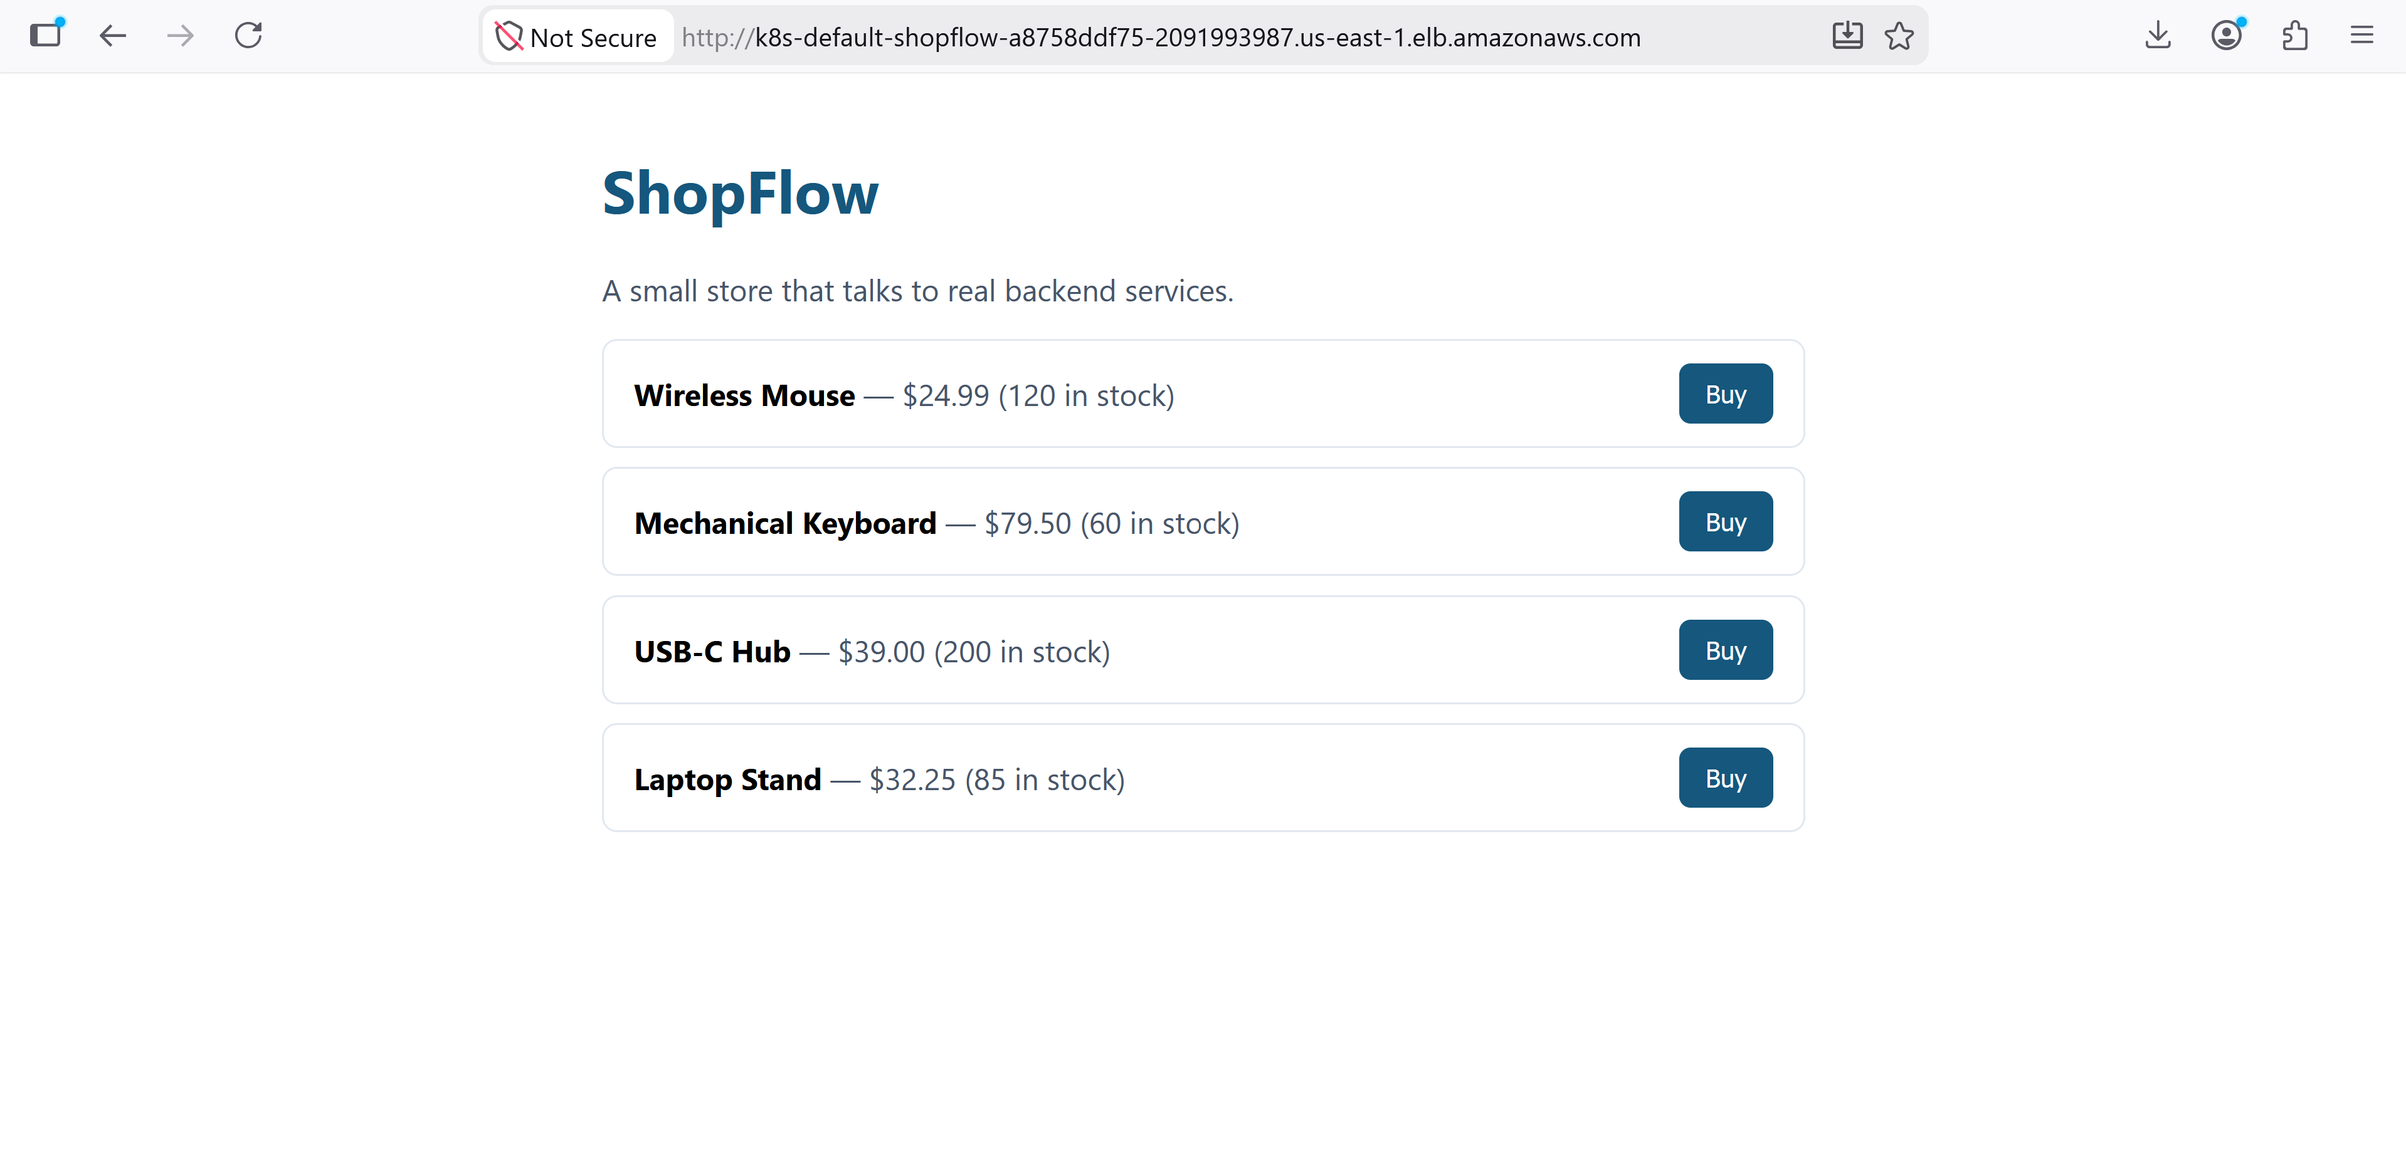
Figure 1: Kubernetes pods for all four ShopFlow services running successfully on the EKS cluster.
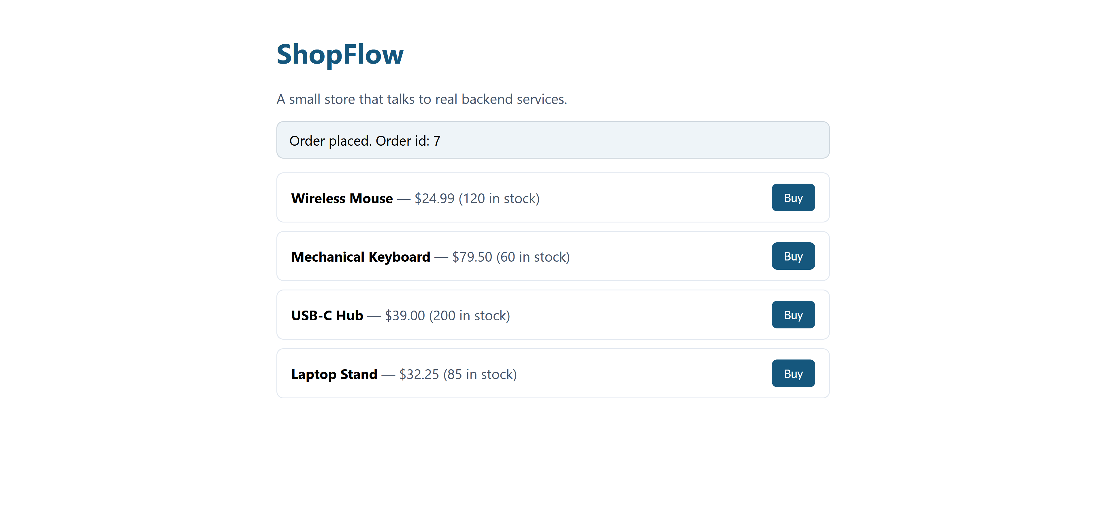
Figure 2: Terraform output confirming the AWS infrastructure was provisioned — EKS cluster, ECR repositories, RDS endpoint, and SQS queue.
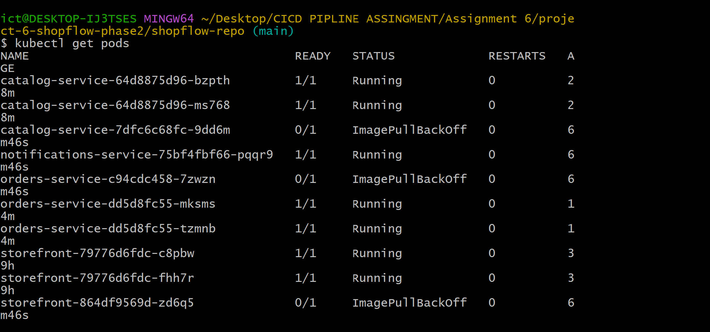
Figure 3: The ShopFlow storefront running in the browser, reachable through the AWS Application Load Balancer.
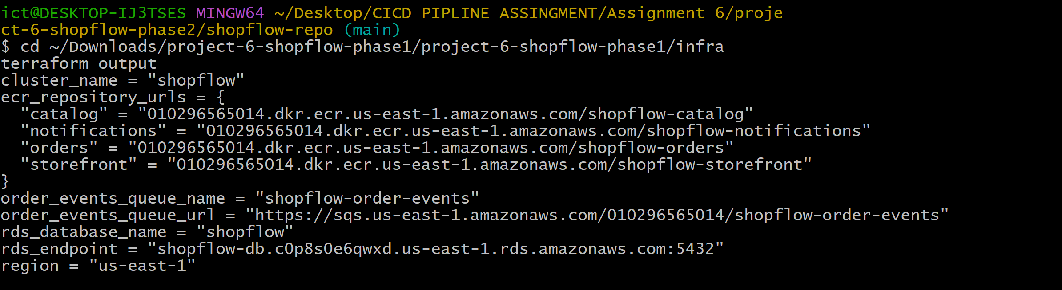
Figure 4: Order confirmation returned after placing an order, proving the full request path — Storefront → Orders → Catalog → RDS → SQS → Notifications — works end to end.

4. Phase 2 — Operating the Platform
Phase 2 layered production-style operational concerns on top of the working Phase 1 system, one capability at a time: secrets management, pod-level AWS identity, observability, autoscaling, and a proper Helm-based deployment model.

4.1 Secrets Management and Pod Identity (IRSA)
Database credentials were moved out of a hand-typed Kubernetes Secret and into AWS Secrets Manager, synced into the cluster automatically by the External Secrets Operator. Separately, IAM Roles for Service Accounts (IRSA) was configured so that application pods authenticate to AWS services (SQS, Secrets Manager) using short-lived, scoped credentials rather than static keys.
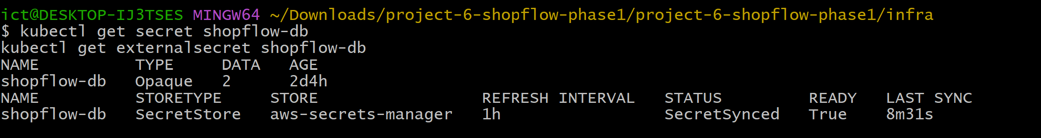
Figure 5: The ExternalSecret resource showing SecretSynced status — confirming the database credential is being pulled live from AWS Secrets Manager rather than stored in the cluster by hand.
Figure 6: IAM service accounts bound to the EKS cluster via IRSA, each with its own scoped IAM role for SQS and Secrets Manager access.

4.2 Monitoring and Observability
The kube-prometheus-stack (Prometheus, Grafana, Alertmanager) was installed and wired to scrape each Spring Boot service's /actuator/prometheus endpoint via a ServiceMonitor. A custom Grafana dashboard was built to track request rate, latency, and error rate per service.
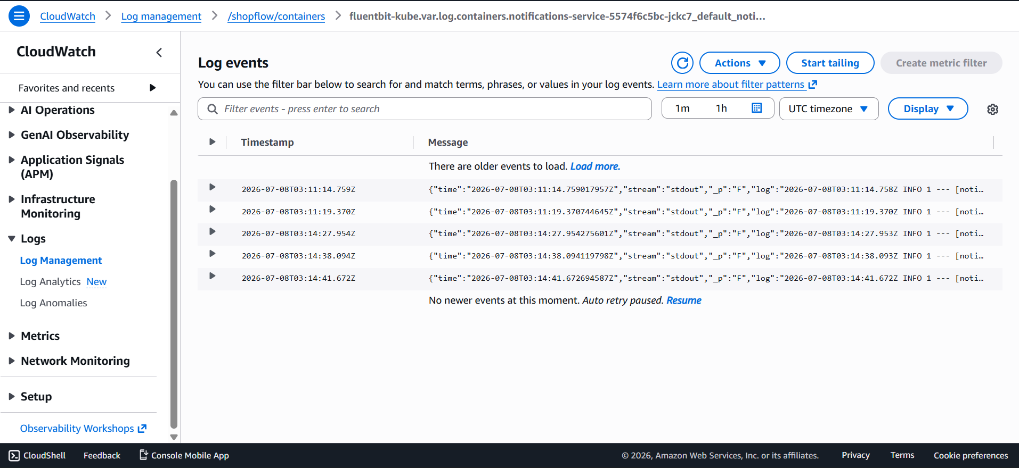
Figure 7: Grafana dashboard showing live request-rate traffic across the Catalog, Orders, and Notifications services after real orders were placed through the storefront.
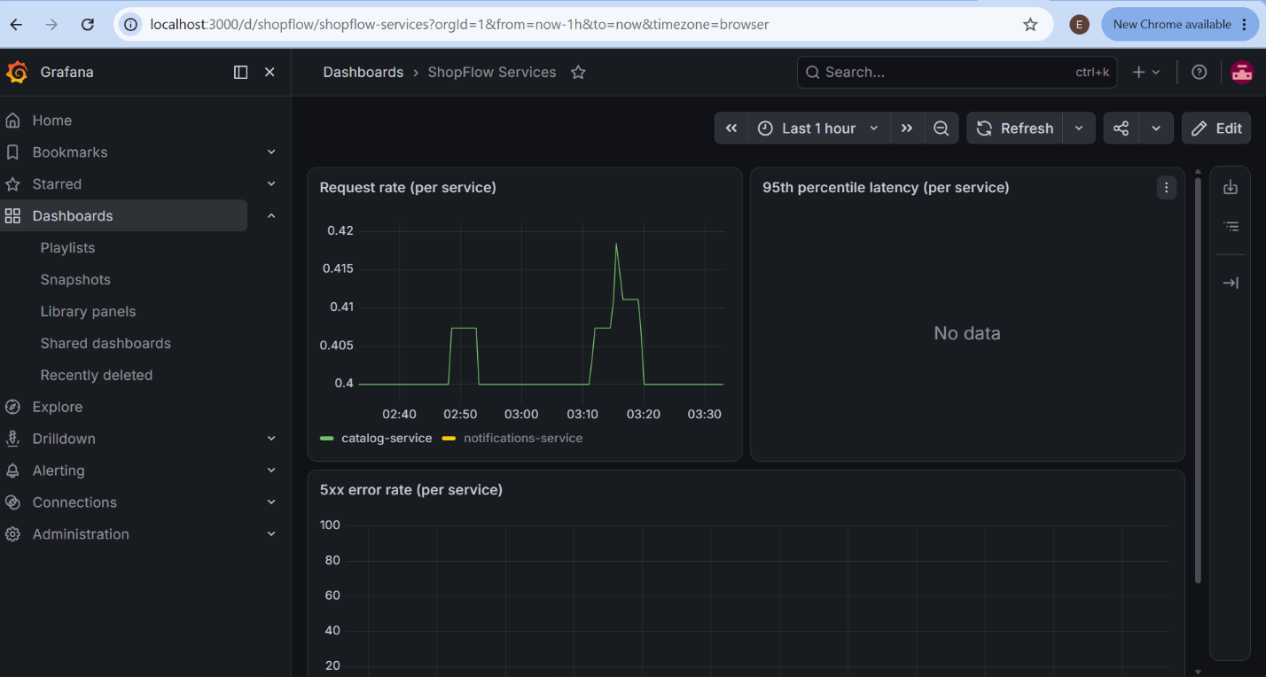
Figure 8: Additional Grafana panels confirming the monitoring pipeline — Prometheus scraping, metric export, and dashboard rendering — is functioning correctly end to end.

4.3 Autoscaling and Deployment via Helm
Horizontal Pod Autoscalers were configured for every service, backed by the Kubernetes metrics-server. The Phase 1 hand-applied manifests were retired in favor of a single Helm chart (helm/shopflow) that defines hardened, non-root pods, resource limits, network policies, the ServiceMonitor, and the autoscaling configuration in one place.
Figure 9: kubectl get hpa showing live CPU utilization percentages for each service, confirming the metrics pipeline required for autoscaling is functioning (rather than showing the default <unknown> state).
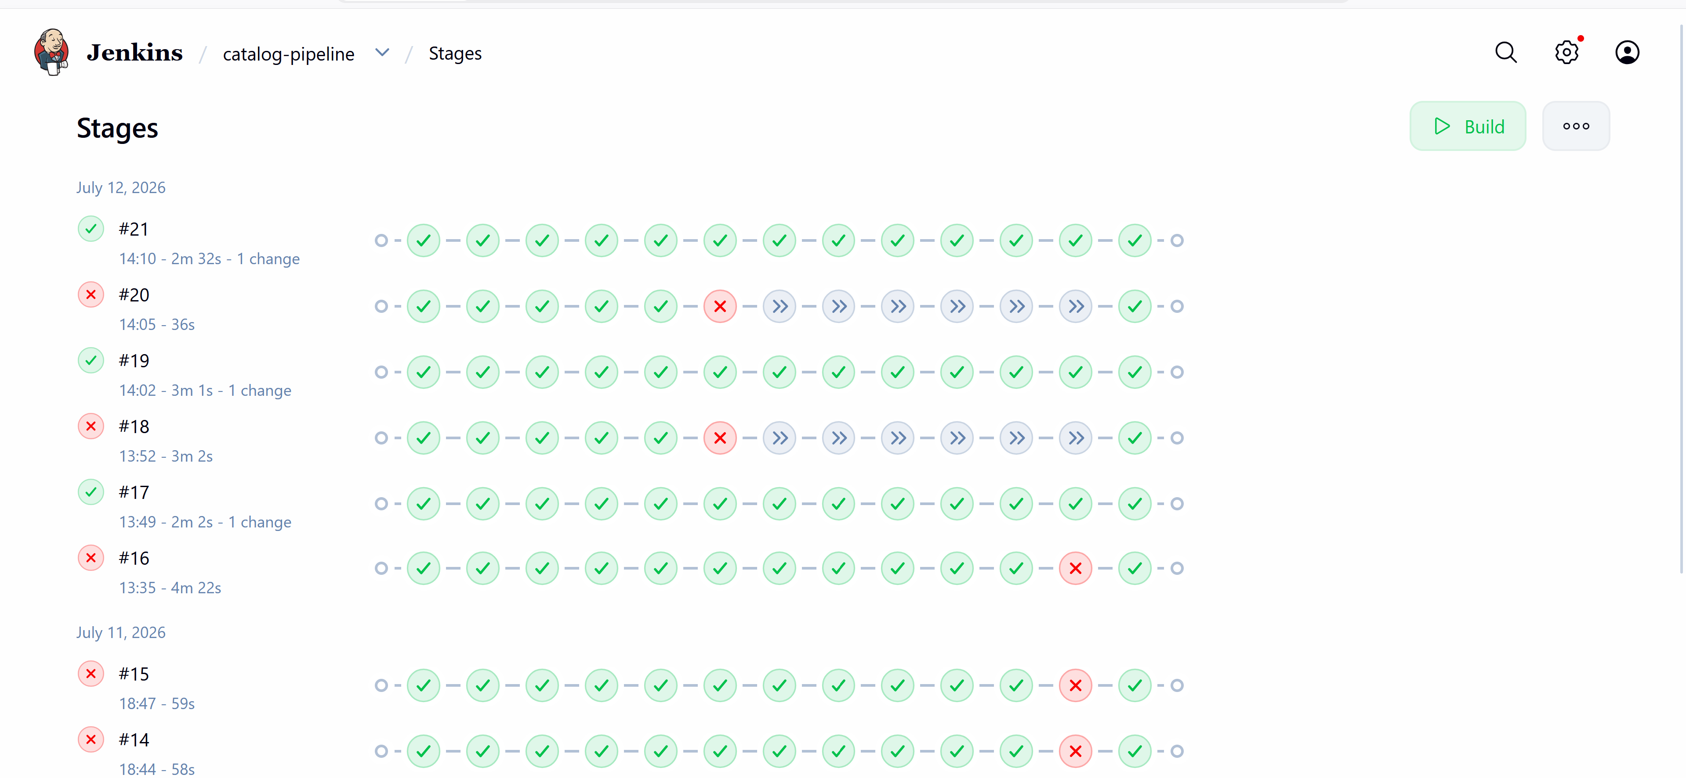
Figure 10: Successful Helm release — helm upgrade --install reporting STATUS: deployed after the chart cutover from the original hand-applied Phase 1 manifests.
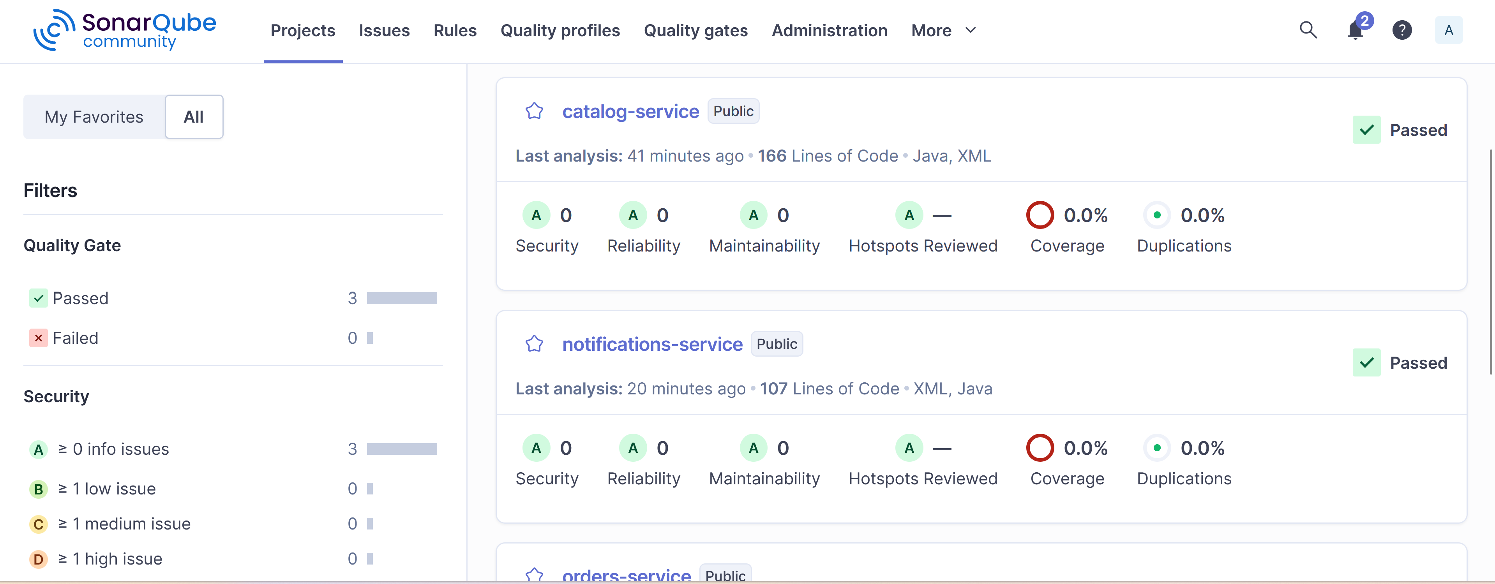
Figure 11: All application pods Running and Ready after the Helm-managed deployment, including the hardened, non-root containers introduced in Phase 2.

5. CI/CD Pipeline
The final stage of the project replaced manual builds and deployments with a fully automated, gated Jenkins pipeline, standing up Jenkins, SonarQube, and Nexus on a dedicated EC2 instance. For every push to the shopflow GitHub repository, the pipeline for each service runs: compile, unit test, a SonarQube quality-gate check, a Trivy dependency vulnerability scan, packaging, publishing the versioned artifact to Nexus, a Docker image build, a second Trivy scan of the built image, a push to Amazon ECR, and finally a live deployment via helm upgrade — with the pipeline hard-failing at any stage that does not pass.
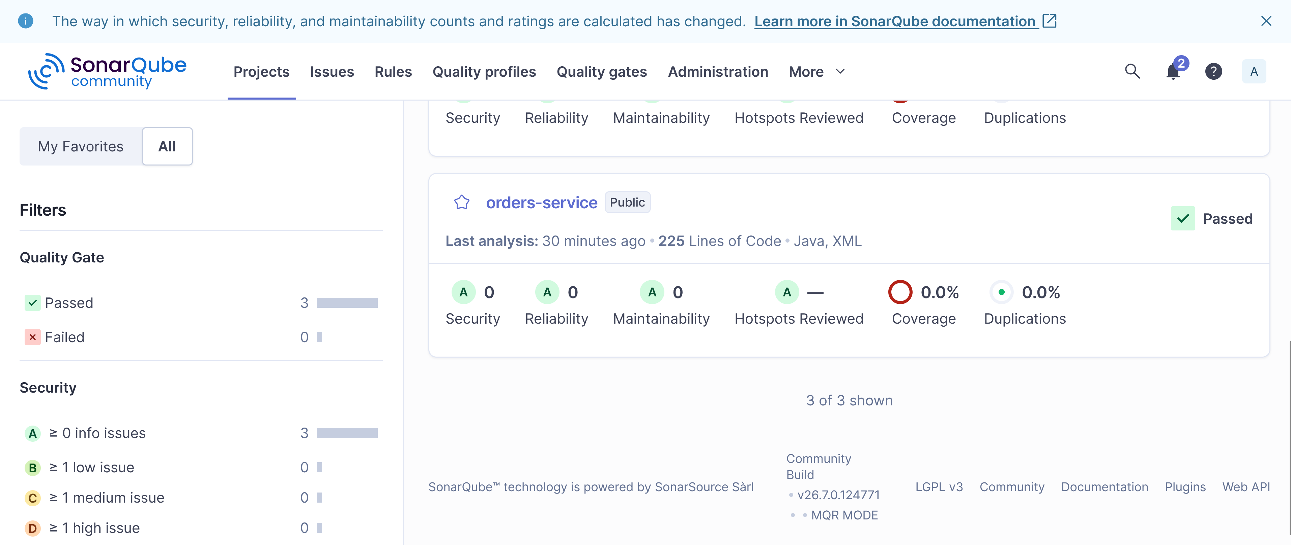
Figure 12: Jenkins console output showing the gated pipeline progressing through its stages — build, test, SonarQube quality gate, and dependency scanning — for one of the three services.
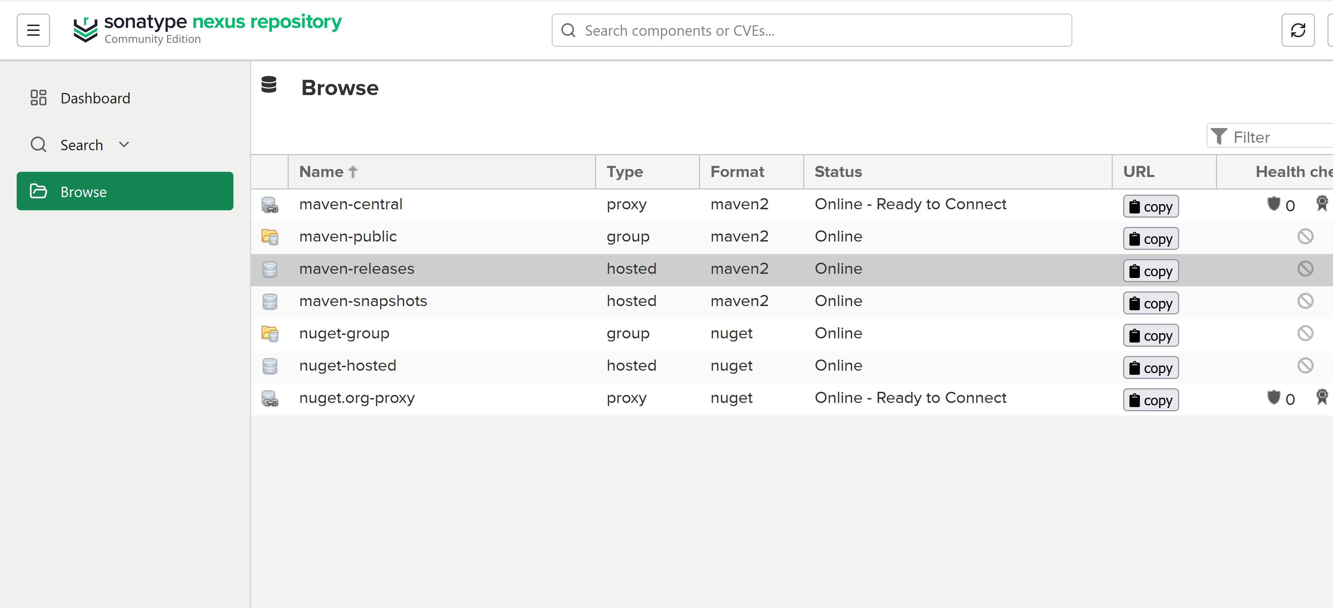
Figure 13: A clean Trivy security scan reporting zero vulnerabilities across the built container image, its base OS packages, and the application JAR, after dependency versions were corrected.
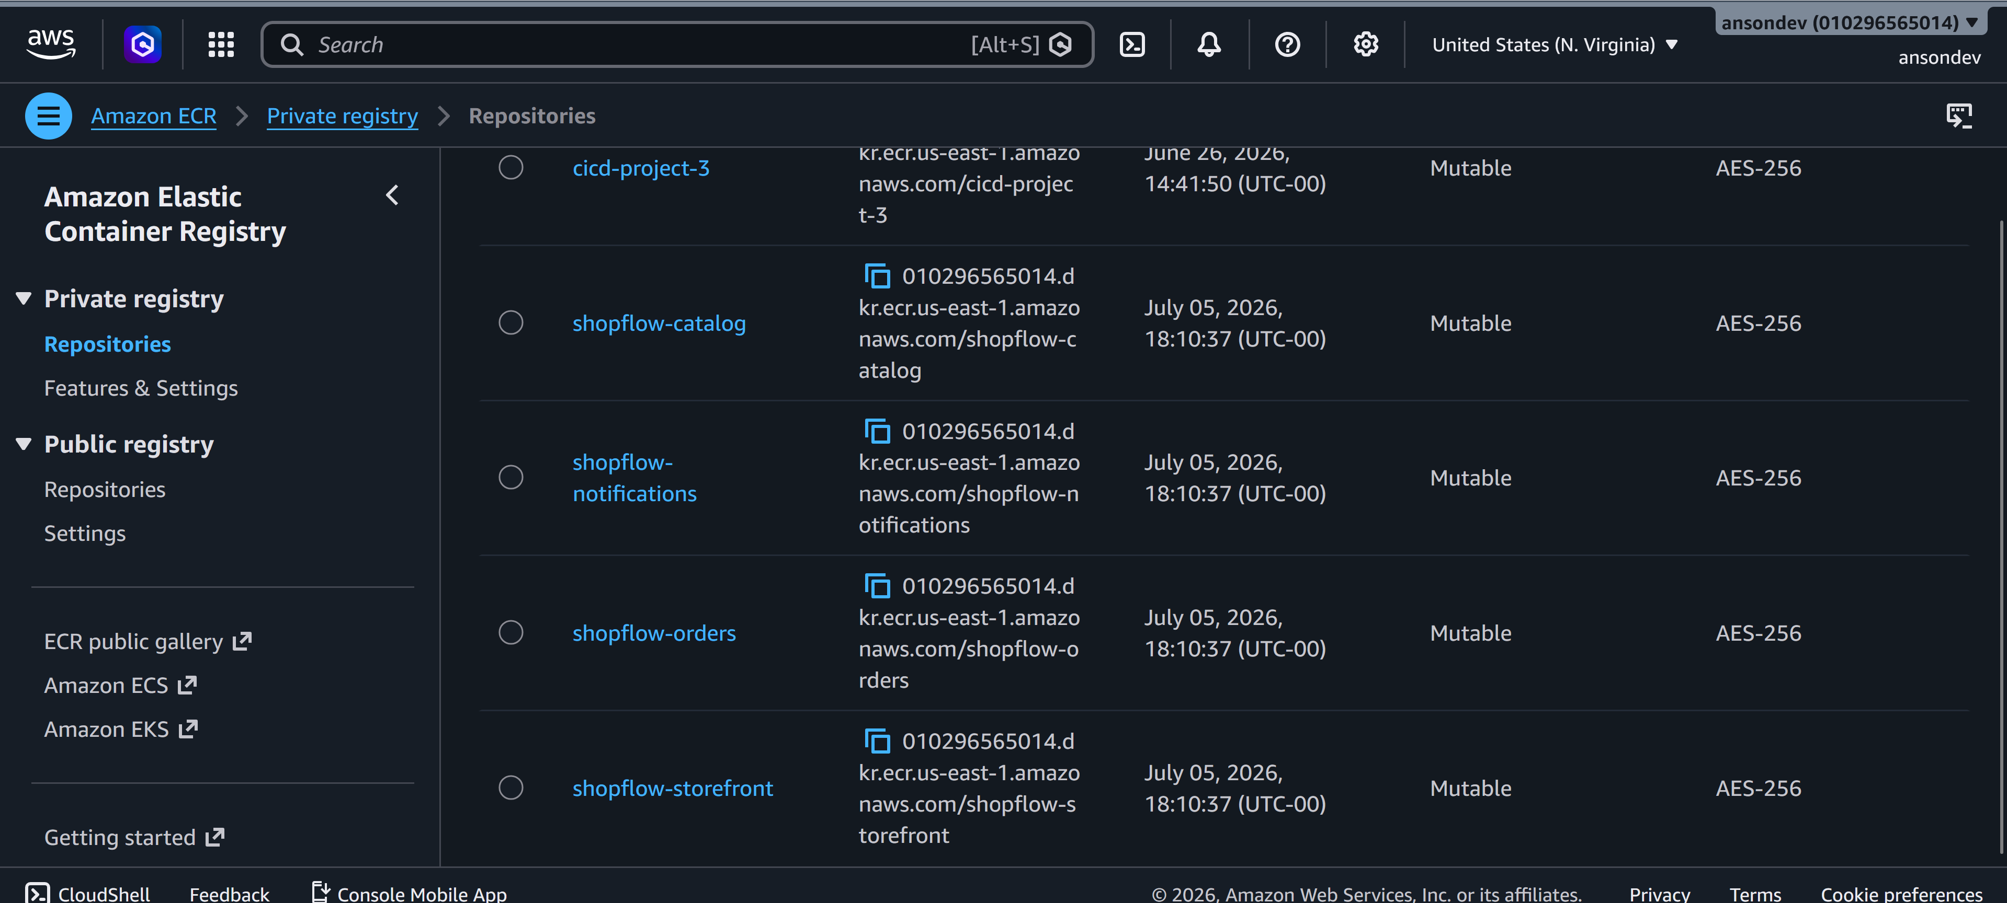
Figure 14: The pipeline's final stage completing successfully — the Docker image is pushed to ECR and helm upgrade deploys it live to the EKS cluster, with kubectl rollout status confirming the new pods became ready.
All three services — Catalog, Orders, and Notifications — were run through this pipeline independently (the Jenkinsfile is parameterized by a SERVICE choice, so one job definition serves all three) and each completed with a full green run: build, test, quality gate, both security scans, artifact publish, image push, and live deployment, all passing.

6. Challenges Faced and How They Were Resolved
Almost every stage of this project surfaced a real infrastructure problem that had to be diagnosed from first principles rather than solved by following the instructions verbatim. The list below is not exhaustive, but captures the issues that took genuine investigation to resolve, in roughly the order they were encountered.

6.1 Load Balancer Controller permissions (Phase 1)
After deploying the Ingress, the AWS Load Balancer Controller failed silently with an AccessDenied error on elasticloadbalancing:DescribeListenerAttributes. The IAM policy that had been attached to the controller's service account was pulled from a pinned, older release tag of the AWS Load Balancer Controller project, which predated an API call the newer controller version required. The fix was to fetch the current policy JSON from the project's main branch, push it as a new IAM policy version, and restart the controller.

6.2 RDS credential drift
A database password set in one terminal session (during the initial terraform apply) was not available in a later session used to build the Kubernetes Secret, because the shell variable holding it did not persist across terminal windows. Rather than guess at the original password, the RDS master password was explicitly reset via the AWS CLI and the Kubernetes Secret was rebuilt from that known value, so the two were guaranteed to match.

6.3 Kubernetes API version mismatch (External Secrets Operator)
Applying the ExternalSecret and SecretStore manifests failed with “no matches for kind”, which read at first like a missing CRD. Checking kubectl api-resources directly showed the CRDs were present, but registered under external-secrets.io/v1, while the manifest had been written against the older external-secrets.io/v1beta1 API version shipped by an earlier version of the operator. Updating the manifest's apiVersion resolved it immediately.

6.4 Helm ownership conflicts during the Phase 1 → Phase 2 cutover
The first helm upgrade --install attempt failed repeatedly because several Kubernetes objects — a ServiceAccount, a ConfigMap, and eventually Deployments and Services — already existed from Phase 1's hand-applied kubectl manifests and lacked the ownership metadata Helm requires to manage a resource. Each conflicting object was identified from the specific error message and deleted individually before re-running the install, since Helm's chart recreated all of them with equivalent (and, for the Deployments, hardened) configuration.

6.5 IAM vCPU quota exhaustion
Launching a dedicated EC2 instance for Jenkins failed with a VcpuLimitExceeded error. Investigation showed the account's on-demand vCPU quota (16) was almost entirely consumed by the EKS cluster's six worker nodes, plus a second, unrelated EKS cluster (cicd-cluster) left over from an earlier assignment and running a small idle deployment. That second cluster was torn down cleanly with eksctl delete cluster, freeing enough quota to launch the Jenkins host without requesting a quota increase from AWS.

6.6 Nexus artifact publishing authentication
The Jenkinsfile's Maven deploy:deploy-file step passed Nexus credentials as command-line -Dusername/-Dpassword flags, which the Maven Deploy Plugin does not reliably honor for authentication, resulting in a persistent 401 Unauthorized. The project already shipped a settings-nexus.xml intended for this purpose, but the pipeline never referenced it. The fix was to pass -s settings-nexus.xml explicitly and inject the Jenkins credential into the environment variables the settings file expects.

6.7 Docker-in-Docker socket permissions
Once Nexus publishing was fixed, the Docker Build stage failed with permission denied on the Docker socket. The custom Jenkins image had the Docker CLI installed, but the jenkins user inside the container did not belong to the host's docker group. The fix was to identify the actual GID owning /var/run/docker.sock on the EC2 host and add it as a supplementary group (group_add) on the Jenkins container in docker-compose.yml.

6.8 AWS access-key transcription and EKS IAM permissions
Pushing to ECR failed with an IncompleteSignatureException, which turned out to be a corrupted secret access key introduced during copy-paste into the Jenkins credential store; generating and re-entering a fresh key pair resolved it. The next run then failed with eks:DescribeCluster access denied — the IAM policy originally attached to the CI/CD IAM user (AmazonEKSClusterPolicy) is intended for the EKS service role, not for a caller invoking aws eks update-kubeconfig, and a narrow inline policy granting exactly that action had to be added instead.

6.9 EKS network access from a new subnet
Even after IAM access was fixed, helm upgrade timed out trying to reach the cluster's private API endpoint. Because the EKS cluster has private endpoint access enabled, any resource inside the VPC — including the newly created Jenkins EC2 instance in its own subnet — resolves the control-plane endpoint to an internal IP, and that traffic was being blocked by the cluster's own security group. Adding an inbound rule allowing HTTPS from the Jenkins subnet resolved it.

6.10 Kubernetes RBAC vs. EKS access policies
Helm's upgrade then failed on a further permissions error, this time inside Kubernetes itself: the CI/CD IAM user could not read the custom ServiceMonitor resource created in Phase 2, even after being granted the EKS-managed “Admin” access policy. This exposed a real limitation of EKS's built-in access policies — they map to a fixed set of resource types and do not automatically extend to every CRD installed by an add-on such as the Prometheus Operator. The fix was to bind the IAM user directly to Kubernetes' own cluster-admin ClusterRole via a standard RBAC ClusterRoleBinding, bypassing the EKS access-policy layer entirely for this identity.

6.11 A silent Helm type-coercion bug
Even with every permission fixed, the very last pipeline stage failed: new pods for the deployed service were stuck in InvalidImageName. The rendered image tag was showing as the literal string %!s(int64=16) — a Go template formatting error. Helm's --set flag automatically infers the type of a value, and because the numeric build number looked like an integer, it was passed into a template that expected a string. Switching the Jenkinsfile from --set image.tag=... to --set-string image.tag=... forced Helm to treat the value as text and resolved it.

6.12 Vulnerable transitive dependencies caught by the pipeline's own security gate
Once the pipeline could run end to end, Trivy's dependency scan legitimately failed the build for all three services, flagging real HIGH and CRITICAL CVEs in Jackson, embedded Tomcat, the PostgreSQL JDBC driver, and (for the two services using Spring Cloud AWS) the Netty networking library. Rather than loosen the security gate, each service's pom.xml was updated: the Spring Boot parent version was upgraded, PostgreSQL and Tomcat/Jackson versions were pinned explicitly via dependencyManagement, and a Netty BOM import was added to pin every Netty module to a single patched release. Each fix was verified locally with a Maven build and a fresh Trivy scan before being committed, and the final scans for all three services returned zero vulnerabilities.

6.13 Environment and tooling friction
A number of smaller but time-consuming issues came from the local Windows/Git Bash environment rather than AWS or Kubernetes: multi-line heredocs and sed commands were repeatedly mangled by the terminal's line-wrapping, a change of network (and therefore public IP) silently locked the team out of SSH and every service port until the security group rules were updated, and a base Jenkins Docker image needed several Dockerfile package-name corrections (Debian's repository does not carry every package under the same name as documentation examples typically assume) before it would build. None of these were conceptually difficult, but each cost real time to isolate from the more substantive infrastructure issues happening in parallel.

7. Conclusion
By the end of the project, ShopFlow was a fully working, observable, and automatically deployed microservices platform: four services running on EKS behind an ALB, backed by RDS and SQS, secured with IRSA and Secrets Manager, monitored with Prometheus and Grafana, centrally logged to CloudWatch, autoscaled via HPA, packaged as a single Helm chart, and shipped through a gated Jenkins pipeline with SonarQube and Trivy enforcing quality and security before anything reaches the cluster. The individual technologies involved — Terraform, EKS, Helm, IAM/IRSA, Prometheus, Jenkins, SonarQube, Trivy, Nexus — are each reasonably well documented in isolation; the real difficulty, and the real learning, was in the seams between them: IAM policies that looked sufficient but weren't, API versions that had quietly moved on, and a security gate that worked exactly as intended and had to be satisfied rather than bypassed. That debugging process is, in the end, the most transferable part of the project.

